Dear Prospective Sponsor,

Thank you for taking the time to consider sponsoring the Valley Sharks cheerleading team from the Cheer Sport Sharks Orillia. This letter briefly provides a further understanding of our athletes and what your sponsorship means to them. The Valley Sharks are an All girl Allstar cheerleading team made up of twenty athletes aged eleven to sixteen years old. This team has been training together since the season started in June 2022. Earning a bid invitation to the Allstar World Cheerleading Championships is a dream come true for these athletes. This competition is held in Florida in May 2023, and is one of the most prestigious events in cheerleading, that some athletes only dream about.

The Valley sharks are a part of the Cheer Sport Sharks Orillia and are connected to The Cheer Sport Sharks family which has locations across Canada and the United States. Cheer Sport Sharks takes great pride in helping children of all ages develop physically, mentally, emotionally and morally through athletics and training. Allstar cheerleading is a very competitive sport throughout our country and the world.

As you can imagine, with this once in a lifetime opportunity comes costly fees, fundraising is necessary in order to assist our cheerleaders with their competition expenses for the Allstar World Cheerleading Championships. These young athletes work diligently to raise money through various methods, and your sponsorship would mean the world to them. We invite you to please help these young athletes by sponsoring them towards their cheer expenses. As a sponsor your business will enable these cheerleaders to participate in a once in a lifetime competition. Show your commitment to the future of these athletes as well as the community. Sponsors will have their logo added to a banner that will be used in team photos and will be listed on our facebook business page and shared with our membership throughout social media. If interested in this opportunity, please fill out the attached form below and send with a cheque made payable to *Teanna Haily Marika Larmand* (owner of CSS Orillia). Thank you for supporting these talented athletes. If you have any questions please contact either our head of the fundraising committee Shannon or our head coach Kira.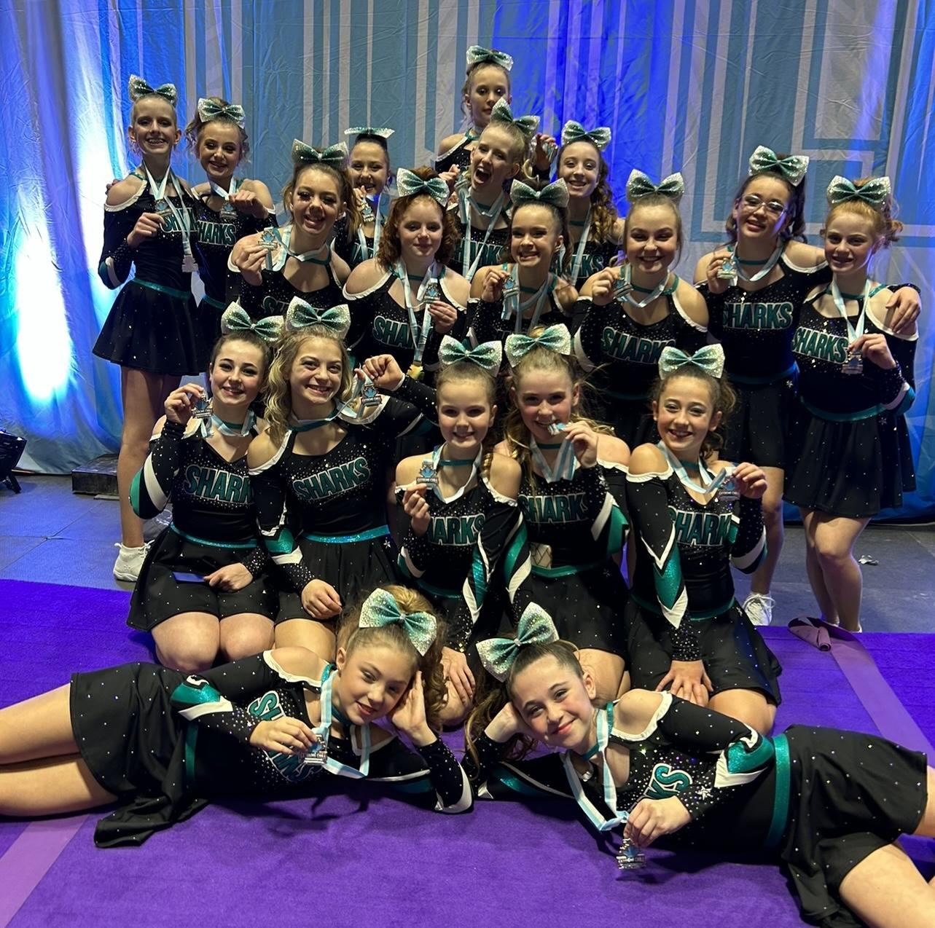

Sincerely,

The Valley Sharks

Shannon 705 345 0443

Kira 705 427 6356

Sponsorship Information

Company Name / Sponsorship Name:

.

Address:

.

City: . Province: .

Postal Code: . Phone Number: .

Website: .

Email Contact: .

Amount of Sponsorship: .

Please make cheque payable to *Teanna Haily Marika Larmand* (Owner of CSS Orillia).